PROBLEM: ERRORIMAGE or IMAGE PULL ERROR  
  
STEP1: Verify the image path configuration on the workload yaml level whether the image tag or repository is miss configured.  
STEP2: If the image configuration and latest image is updated in workload level then check with the default service account permissions check.  
STEP3: If the default service account permissions are missed in servie account level, Especially editor role is missing(not able to read the default service account secret)( 413178660353-compute@developer.gserviceaccount.com)  
STEP3:   
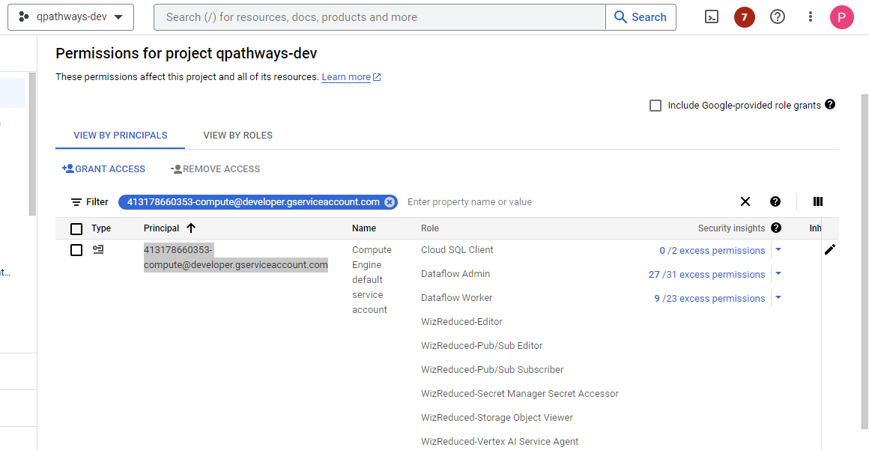  
  
  
  
Ingress Issue:  
 \*If the ingress is mapped with the domain and configure for redirect http to https on this case we need to take care of the service which is using to create the ingress, Because once you remove the service and add again new load balance is created with the new IP on that case previous domain not able to access.  
\*Again we are going to go to load balancer section and removed the existing load balancer and create the new load balancer with the already mapped with the domain.  
\*NOTE:- Whie adding the domain mapping always best practice to use the static IP.